**Practical No. 6 (A)**

**Aim**: Develop a Java application to store image in a database and display all values on the output window in the same application.

Source Code :

package javaapplication5;

import java.beans.Statement;

import java.io.File;

import java.io.FileInputStream;

import java.io.FileNotFoundException;

import java.io.FileOutputStream;

import java.io.InputStream;

import java.io.OutputStream;

import java.sql.Connection;

import java.sql.DriverManager;

import java.sql.PreparedStatement;

import java.sql.ResultSet;

import java.sql.SQLException;

public class ImageUpload {

public static void main(String[] args) throws SQLException, FileNotFoundException

{

try

{

Connection con=DriverManager.getConnection("jdbc:derby://localhost:1527/College","ckt","ckt");

System.out.println("Connection Established");

java.sql.Statement stmt=con.createStatement();

String createTable = "CREATE TABLE Tutorial( "+ "Name VARCHAR(255), "+ "Type VARCHAR(50), " + "Logo BLOB)";

stmt.execute(createTable);

System.out.println("table created");

//Inserting values

String query = "INSERT INTO Tutorial(Name, Type, Logo) VALUES (?, ?, ?)";

PreparedStatement pstmt = con.prepareStatement(query);

pstmt.setString(1, "Advance Java");

pstmt.setString(2, "A Java Practical");

FileInputStream fin = new FileInputStream("D:\\helloji.jpg");

pstmt.setBinaryStream(3, fin);

pstmt.execute();

System.out.println("Data inserted");

ResultSet rs = stmt.executeQuery("Select *from Tutorial");

while(rs.next()) {

System.out.print("Name: "+rs.getString("Name")+", ");

System.out.print("Tutorial Type: "+rs.getString("Type")+", ");

System.out.print("Logo: "+rs.getBlob("Logo"));

System.out.println();

}

}catch(Exception e){

System.out.println("Exception generated: " + e);}

}

}

Output :

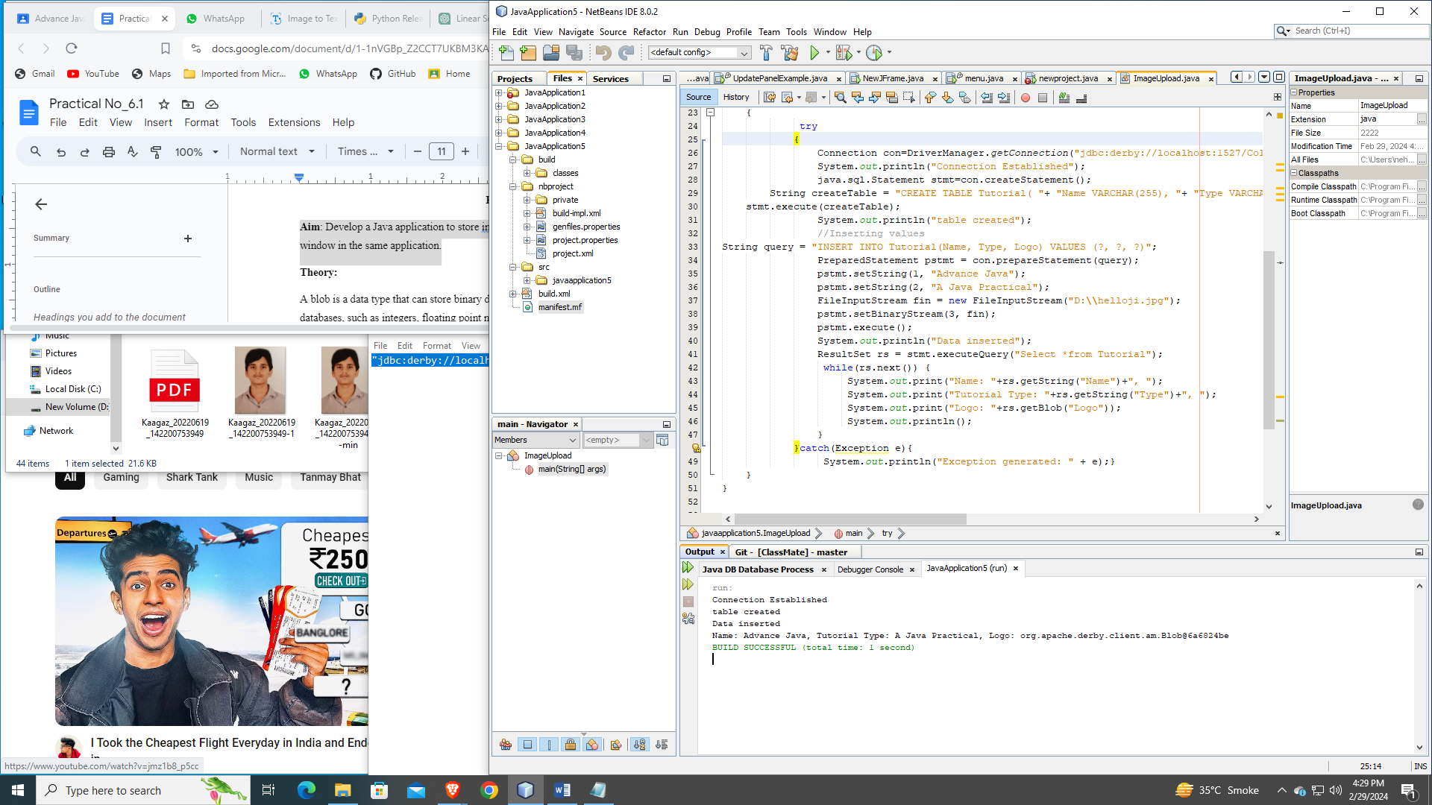

**Practical No. 6 (B)**

**Aim**: Develop a Java application to store image in a database as well as retrieve image from database.

Source Code :

package javaapplication5;

import java.beans.Statement;

import java.io.File;

import java.io.FileInputStream;

import java.io.FileNotFoundException;

import java.io.FileOutputStream;

import java.io.InputStream;

import java.io.OutputStream;

import java.sql.Connection;

import java.sql.DriverManager;

import java.sql.PreparedStatement;

import java.sql.ResultSet;

import java.sql.SQLException;

public class ImageUpload {

public static void main(String[] args) throws SQLException, FileNotFoundException

{

try {

Connection con=DriverManager.getConnection("jdbc:derby://localhost:1527/College","ckt","ckt");

System.out.println("Connection Established");

java.sql.Statement stmt=con.createStatement();

//If table is already created, then comment below statements

/* String createTable = "CREATE TABLE Tutorial( "

+ "Name VARCHAR(255), "

+ "Type VARCHAR(50), "

+ "Logo BLOB)";

stmt.execute(createTable);

System.out.println("table created");*/

//Inserting values

String query = "INSERT INTO Tutorial(Name, Type, Logo) VALUES (?, ?, ?)";

PreparedStatement pstmt = con.prepareStatement(query);

pstmt.setString(1, "Advance Java");

pstmt.setString(2, "A Java Practical");

FileInputStream fin = new FileInputStream("D:\\helloji.jpg");

pstmt.setBinaryStream(3, fin);

pstmt.execute();

System.out.println("Data inserted");

// ResultSet rs = stmt.executeQuery("Select *from Tutorial");

// selecting only logo field from the table

ResultSet rs = stmt.executeQuery("Select logo from Tutorial");

int i=0;

while(rs.next()) {

// below code is used to display output on the output window in the application itself

/* System.out.print("Name: "+rs.getString("Name")+", ");

System.out.print("Tutorial Type: "+rs.getString("Type")+", ");

System.out.print("Logo: "+rs.getBlob("Logo"));

System.out.println();*/

InputStream in=rs.getBinaryStream(1);

OutputStream f=new FileOutputStream(new File("test"+i+".jpg"));

i++;

int c=0;

while((c=in.read())>-1)

{

f.write(c);

}

f.close();

in.close();

}

System.out.println("File is created.");

//To check the image file, Go in Files tab, select your project & expand build.xml, all images with test name will be displayed.");

}catch(Exception e){

System.out.println("Exception generated : " + e); }

}

}

Output :

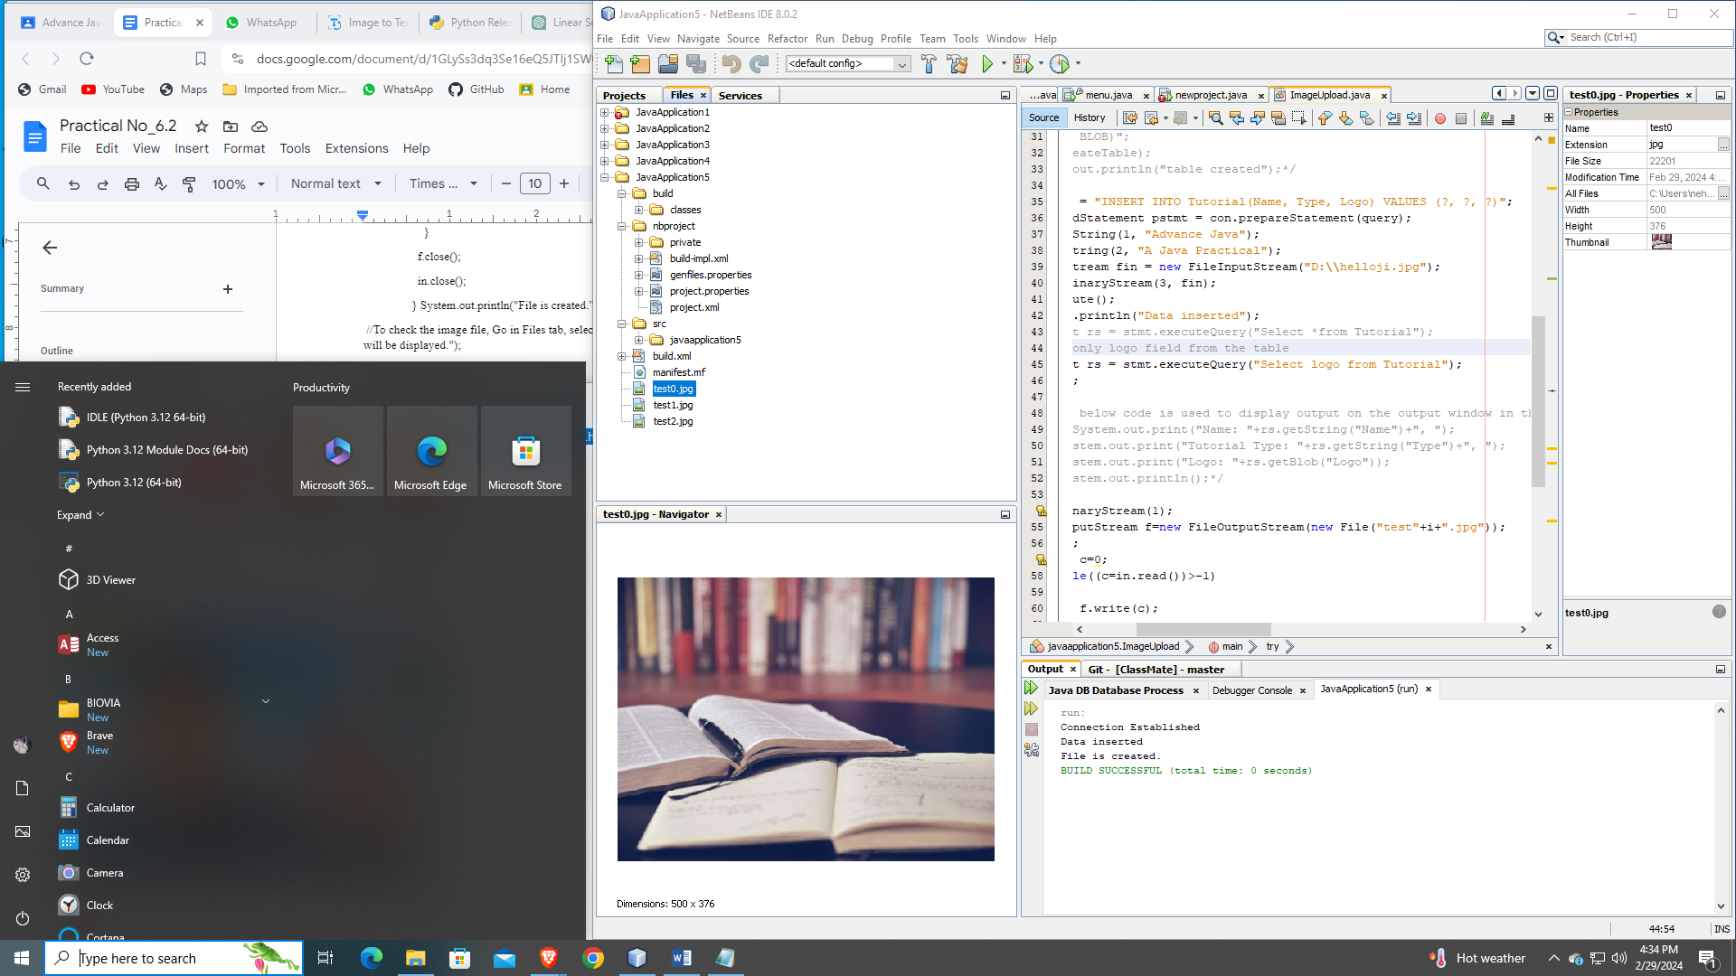

**Practical No. 7**

Aim: Develop a Java application to display current date and time using servlet

Source Code :

import java.io.IOException;

import java.io.PrintWriter;

import javax.servlet.ServletException;

import javax.servlet.annotation.WebServlet;

import javax.servlet.http.HttpServlet;

import javax.servlet.http.HttpServletRequest;

import javax.servlet.http.HttpServletResponse;

@WebServlet(urlPatterns = {"/NewServlet"})

public class NewServlet extends HttpServlet {

protected void processRequest(HttpServletRequest request, HttpServletResponse response)

throws ServletException, IOException {

response.setContentType("text/html;charset=UTF-8");

try (PrintWriter out = response.getWriter()) {

out.println("<!DOCTYPE html>");

out.println("<html>");

out.println("<head>");

out.println("<title>Servlet NewServlet</title>");

out.println("</head>");

out.println("<body>");

out.println("<h1>Servlet displaydate at " + request.getContextPath() + "</h1>");

java.util.Date date = new java.util.Date();

out.println("<h2>"+"Current Date & Time: " +date.toString()+"</h2>");

out.println("</body>");

out.println("</html>");

}

}

}

Output :

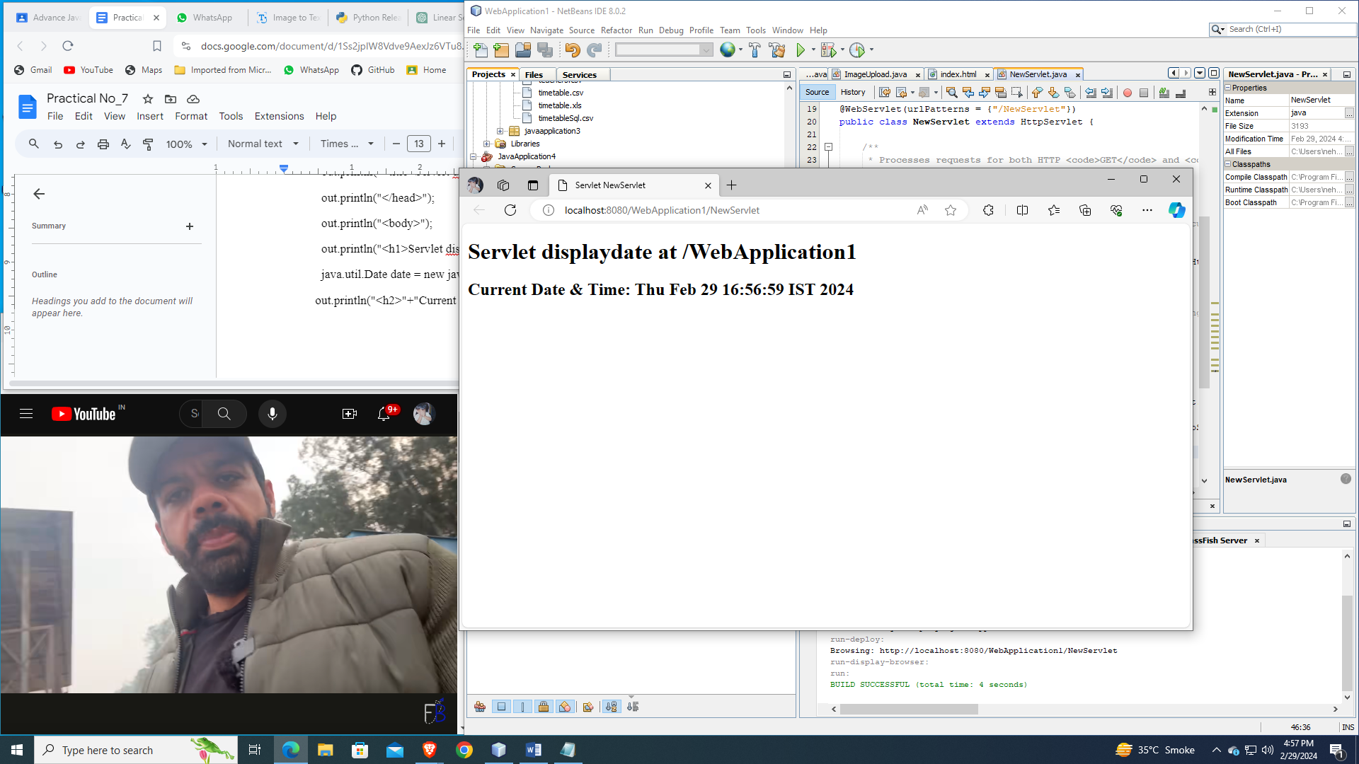

**Practical No. 9**

**Aim:** Design database for student administration. Develop servlet to perform CRUD operations.

Source Code :

Index.html

<!DOCTYPE html>

<html>

<head>

<title>Practical 9</title>

<meta charset="UTF-8">

<meta name="viewport" content="width=device-width, initial-scale=1.0">

</head>

<body>

<form action="tryservlet" method="post">

<h1>Student information</h1>

Roll no<input type="text" name="t1"><br>

Student Name<input type="text" name="t2"><br>

Class<input type="text" name="t3"><br>

<input type="submit" value="submit">

</form>

</body>

</html>

NewServlet.java

import java.io.IOException;

import java.io.PrintWriter;

import static java.lang.System.out;

import java.sql.Connection;

import java.sql.DriverManager;

import java.sql.PreparedStatement;

import java.sql.Statement;

import javax.servlet.ServletException;

import javax.servlet.annotation.WebServlet;

import javax.servlet.http.HttpServlet;

import javax.servlet.http.HttpServletRequest;

import javax.servlet.http.HttpServletResponse;

@WebServlet(name = "tryservlet", urlPatterns = {"/tryservlet"})

public class NewServlet extends HttpServlet {

protected void processRequest(HttpServletRequest request, HttpServletResponse response)throws ServletException, IOException {

response.setContentType("text/html;charset=UTF-8");

String b,c;

int a=Integer.parseInt(request.getParameter("t1"));

b=request.getParameter("t2");

c=request.getParameter("t3");

try{

Connection con=DriverManager.getConnection("jdbc:derby://localhost:1527/College","ckt","ckt");

out.println("Connection successfully");

PreparedStatement psmt=con.prepareCall("insert into student values(?,?,?)");

psmt.setInt(1,a);

psmt.setString(2,b);

psmt.setString(3,c);

psmt.executeUpdate();

out.println("inserted successfully");

Statement stmt=con.createStatement();

stmt.executeUpdate("update student set sname='ckt' where rollno=89");

out.println("update record successfully");

stmt.executeUpdate("delete from student where sname='ckt'");

out.println("Delete record successfully");

}

catch(Exception e){

}

}

@Override

protected void doGet(HttpServletRequest request, HttpServletResponse response)throws ServletException, IOException {

processRequest(request, response);

}

@Override

protected void doPost(HttpServletRequest request, HttpServletResponse response)throws ServletException, IOException {

processRequest(request, response);

}

@Override

public String getServletInfo() {

return "Short description";

}

}

Output :

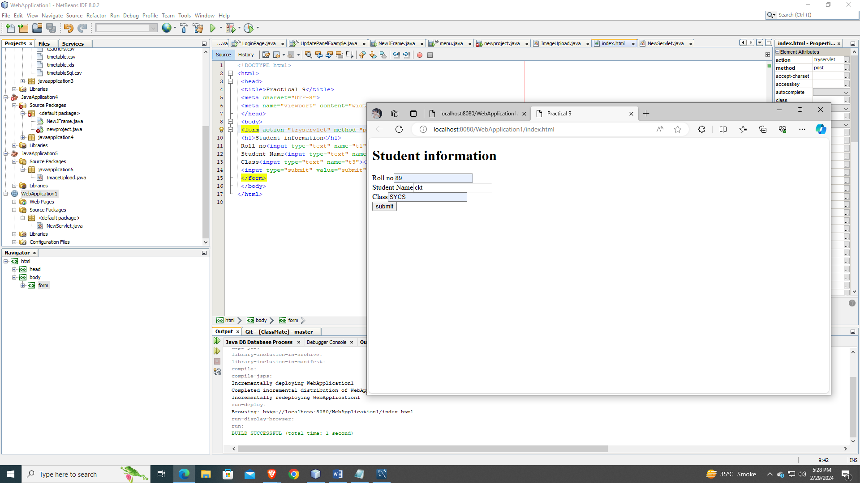

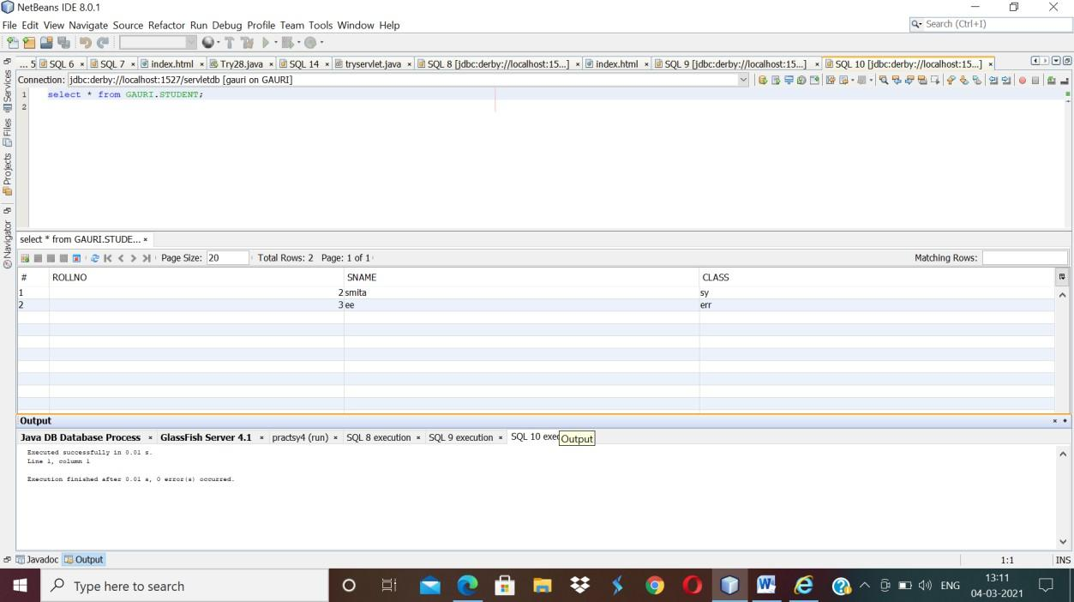

**Practical No. 12**

**Aim:** Database connectivity using JSP

Source Code :

Index.html

<!DOCTYPE html>

<html>

<head>

<title>TODO supply a title</title>

<meta charset="UTF-8">

<meta name="viewport" content="width=device-width, initial-scale=1.0">

</head>

<body>

<form action="newjsp.jsp" method="post">

<h1>Student information</h1>

Roll no<input type="text" name="t1"><br> Student Name<input type="text" name="t2"><br> Class<input type="text" name="t3"><br>

<input type="submit" value="submit">

</form>

</body>

</html>Top of Form

Bottom of Form

newjsp.jsp

<%@page import="java.sql.DriverManager"%>

<%@page import="java.sql.PreparedStatement"%>

<%@page import="java.sql.Connection"%>

<%@page contentType="text/html" pageEncoding="UTF-8"%>

<!DOCTYPE html>

<html>

<head>

<meta http-equiv="Content-Type" content="text/html; charset=UTF-8">

<title>JSP Page</title>

</head>

<body>

<%

String b,c;

int a=Integer.parseInt(request.getParameter("t1")); b=request.getParameter("t2"); c=request.getParameter("t3");

try

{

Connection con=DriverManager.getConnection("jdbc:derby://localhost:1527/College","ckt","ckt");

out.println("Connection successfully");

PreparedStatement psmt=con.prepareCall("insert into student values(?,?,?)"); psmt.setInt(1,a);

psmt.setString(2,b); psmt.setString(3,c); psmt.executeUpdate(); out.println("inserted successfully");

}

catch(Exception e)

{

}

%>

</body>

</html>

Output :

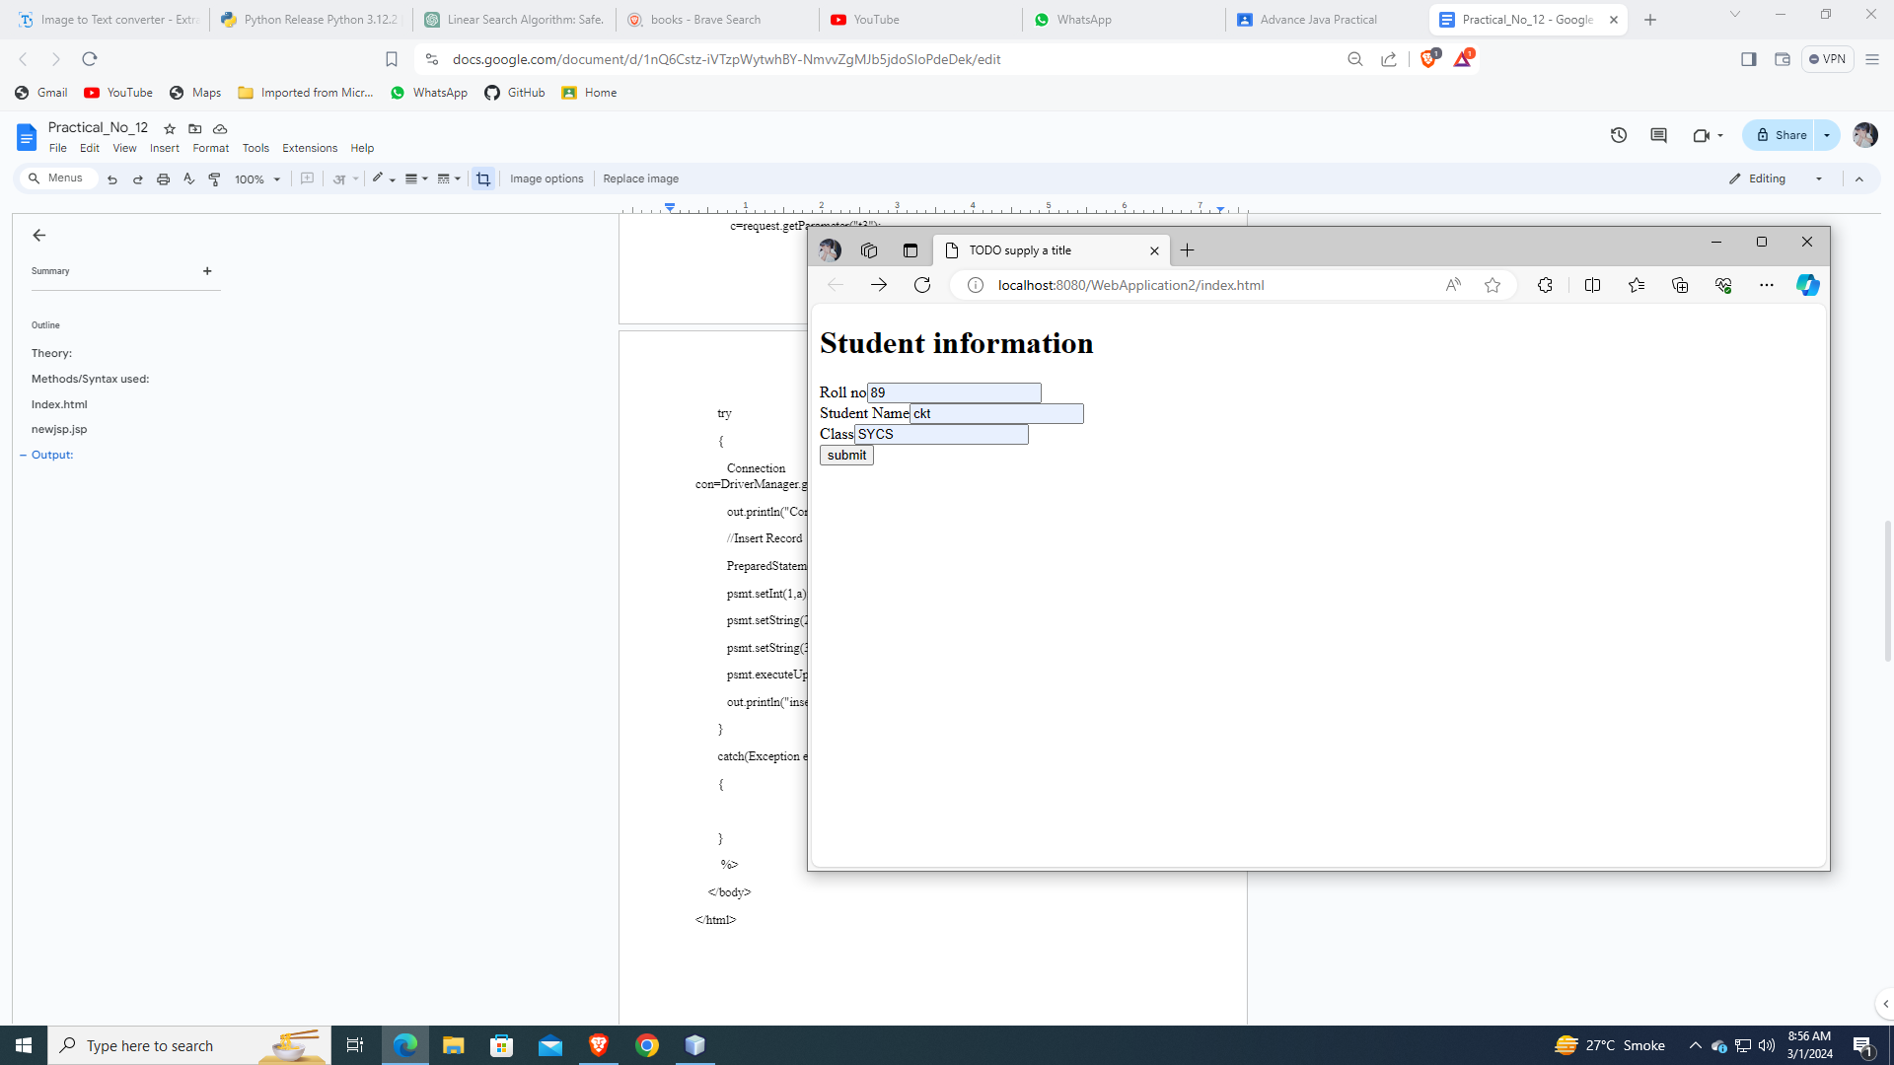 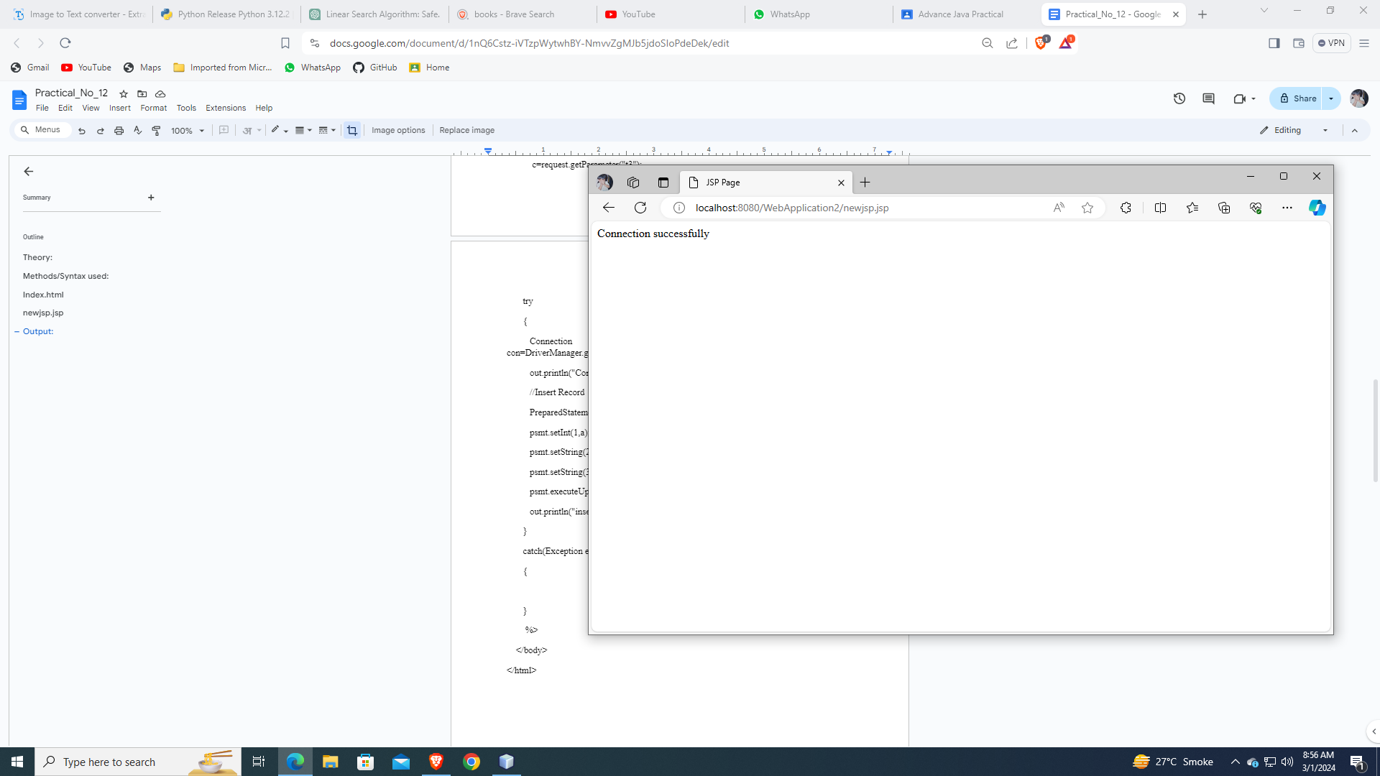

**Practical No. 13**

**Aim:** Write a student class with two properties. The useBean action declares a JavaBean for use in a JSP. Write Java application to access JavaBeans Properties.

Source Code :

StudentBean.java

package newpackage;

public class StudentBean implements java.io.Serializable{

private String firstName = null;

private String lastName = null;

public StudentBean() {

}

public String getFirstName(){

return firstName;

}

public String getLastName(){

return lastName;

}

public void setFirstName(String firstName){

this.firstName = firstName;

}

public void setLastName(String lastName){

this.lastName = lastName;

}

}Top of Form

Bottom of Form

newjsp.jsp

<%@page contentType="text/html" pageEncoding="UTF-8"%>

<!DOCTYPE html>

<html>

<head>

<meta http-equiv="Content-Type" content="text/html; charset=UTF-8">

<title>JSP Page</title>

</head>

<body>

<h4> In jsp file we used javabean getter & setter method</h4>

<jsp:useBean id = "students" class = "newpackage.StudentBean">

<jsp:setProperty name = "students" property = "firstName" value="hello"/>

<jsp:setProperty name = "students" property = "lastName" value="world"/>

</jsp:useBean>

<p>Student First Name:

<jsp:getProperty name = "students" property = "firstName"/>

</p>

<p>Student Last Name:

<jsp:getProperty name = "students" property = "lastName"/>

</p>

</body>

</html>

Output :

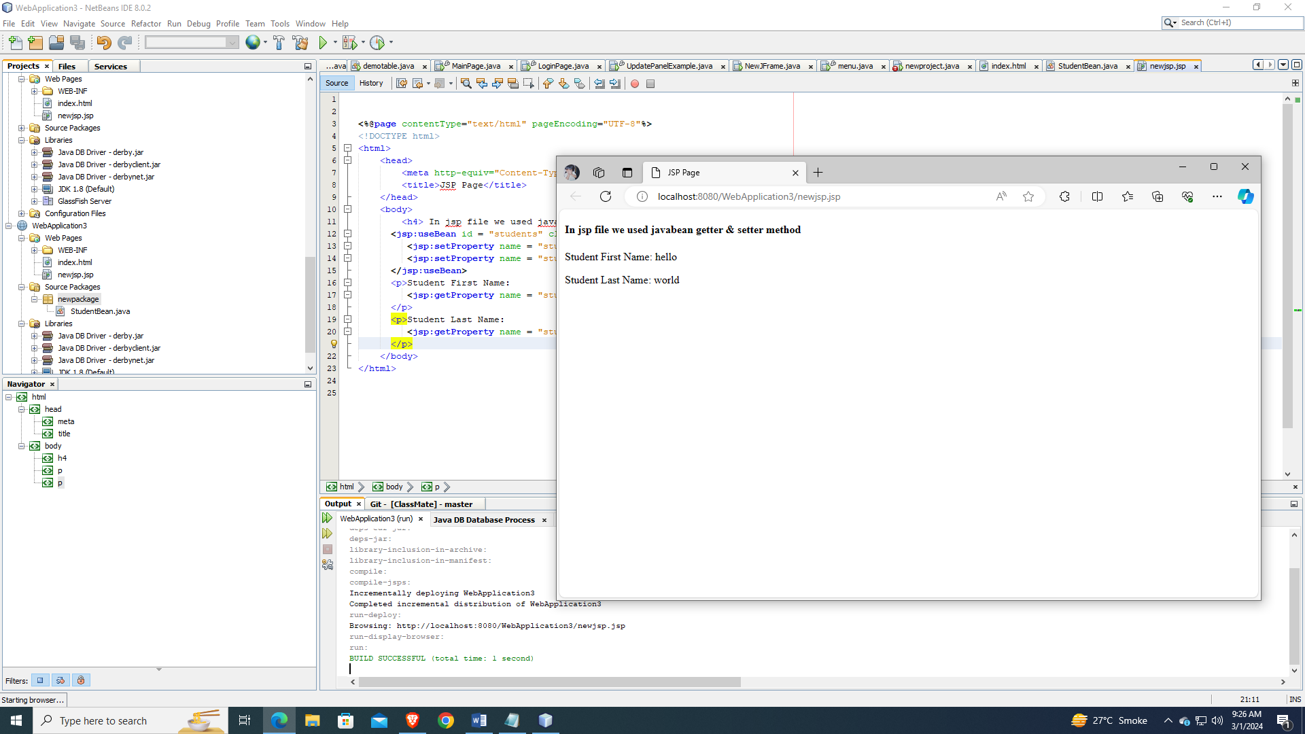

**Practical No. 15**

**Aim:** Write Java application to perform encoding and decoding JSON in Java.

Source Code :

JSONExampleClass.java

package json;

import org.json.simple.JSONObject;

public class JSONExampleClass

{

public static void main(String args[]){

JSONObject obj=new JSONObject();

obj.put("name","ckt college");

obj.put("year of establishment",new Integer(1950));

obj.put("salary of employee",new Double(600000));

System.out.print(obj);

}

}

Top of Form

Output :

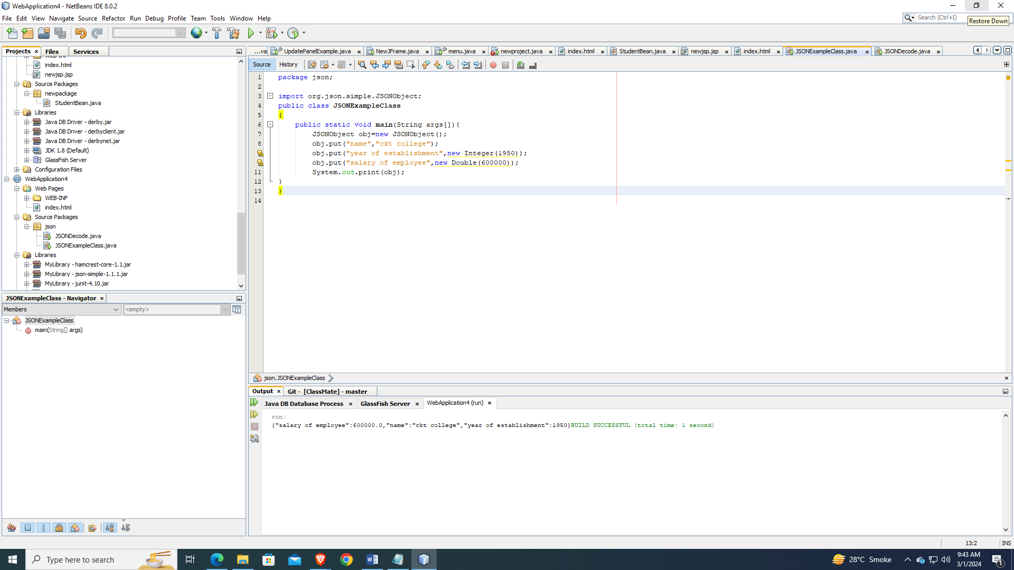

Source Code :

Bottom of Form

JSONDecode.java

package json;

import org.json.simple.JSONObject; import org.json.simple.JSONValue;

public class JSONDecode

{

public static void main(String[] args) {

String s="{\"name\":\"ckt college\",\"year of establishment\":1950,\"salary\":600000.0}";

Object obj=JSONValue.parse(s);

JSONObject jsonObject = (JSONObject) obj;

String name = (String) jsonObject.get("name");

long year = (Long) jsonObject.get("year of establishment");

double salary = (Double) jsonObject.get("salary");

System.out.println(name+" "+year+" "+salary);

}

}

Output :

